13.2 Reactivity series
Name: ____________________ Class: ____________________ Due date: 5.20
1. Samples of five different metals, E, F, G, H and J were reacted with dilute sulfuric acid using the apparatus shown.
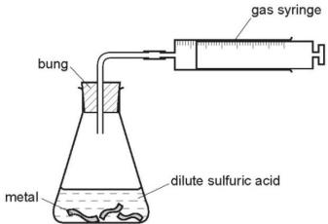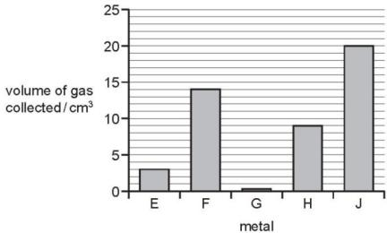
The volume of hydrogen gas collected after one minute was measured.
The results are shown on the bar chart.
What is the order of reactivity of the metals (most reactive first)? （ ）
A. E,F,G,H,J B. G,E,H,F,J C. J,F,H,E,G D. J,H,G,F,E

2. Metal X reacts violently with water. Metal Y reacts slowly with steam.
Metal Z does not react with dilute hydrochloric acid.
What is the correct order of reactivity of these metals, most reactive first? （ ）
A $X→Y→Z$ B $X→Z→Y$ C $Z→X→Y$ D $Z→Y→X$

3. Y displaces X from its aqueous sulfate.
X does not displace W from its aqueous sulfate.
X displaces Z from its aqueous sulfate.
What is the order of reactivity of elements W, X, Y and Z? （ ）
 | most reactive | least reactive
A | W | X | Y | Z
B | W | Y | X | Z
C | Z | X | Y | W
D | Z | W | Y | X

4. A student carried out an experiment to find the order of reactivity of five metals. They were tested with cold water, hot water and steam and results recorded in table.
metal | cold water | hot water | steam
V | no reaction | reacts slowly | vigorous reaction
W | no reaction | no reaction | slow reaction
X | reacts slowly | vigorous reaction | not attempted
Y | no reaction | no reaction | no reaction
Z | vigorous reaction | explosive reaction | not attempted
What is the order of reactivity of these metals? （ ）
 | most reactive |  |  | least reactive
A | V | W | Y | X | Z
B | W | X | Z | V | Y
C | Z | X | V | W | Y
D | Z | X | Y | W | V
5. Metal X reacts with steam but not with cold water.
What is X? （ ）
A calcium B copper C sodium D zinc

6. Pieces of copper, iron, magnesium and zinc are added to separate test- tubes containing dilute hydrochloric acid.
Which test- tube contains iron and dilute hydrochloric acid? （ ）
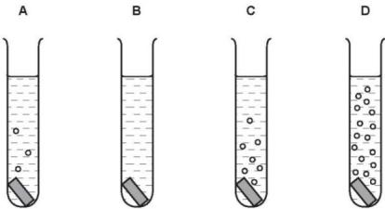

7. Which substances do not react together? （ ）
A calcium + water
B copper + dilute hydrochloric acid
C sodium + water
D zinc + dilute hydrochloric acid

8. The ionic equations represent the reactions between four metals, P, Q, R and S, and solutions of the salts of the same metals.
$$\begin{aligned}&\text{P}+{\text{Q}}^{2+}→\text{no} \text{reaction} \\ &\text{R}+{\text{P}}^{2+}→{\text{R}}^{2+}+\text{P} \\ &\text{Q}+{\text{S}}^{2+}→{\text{Q}}^{2+}+\text{S} \\ &\text{S}+{\text{P}}^{2+}→{\text{S}}^{2+}+\text{P} \\ &\text{S}+{\text{R}}^{2+}→{\text{S}}^{2+}+\text{R} \\ &\text{S}+{\text{Q}}^{2+}→\text{no} \text{reaction}\end{aligned}$$
What is the correct order of reactivity of the metals? （ ）
 | most | least
A | P | R | S | Q
B | Q | R | S | P
C | Q | S | R | P
D | S | Q | P | R

9. The results of two experiments are given.
1 Cobalt displaces manganese from an aqueous solution of a manganese salt.
2 Manganese displaces silver from an aqueous solution of a silver salt.
Three more experiments are carried out.
3 Cobalt is added to an aqueous solution of a silver salt.
4 Manganese is added to an aqueous solution of a cobalt salt.
5 Silver is added to an aqueous solution of a cobalt salt.
In which experiments does a reaction take place? （ ）
A 3 only B 3 and 4 C 4 and 5 D 5 only
10. The section of the reactivity series shown includes a newly discovered element, symbol X.
The only oxide of X has the formula XO.
Ca Mg Fe X H Cu
Which equation shows a reaction which occurs? （ ）
A $Cu(s)+X^{2+}(aq)→{Cu}^{2+}(aq)+X(s)$
B $2X(s)+{Cu}^{2+}(aq)→2X^{+}(aq)+Cu(s)$
C $X(s)+{Fe}_{2}O_{3}(s)→2Fe(s)+3XO(s)$
D $X(s)+2HCl(aq)→{XCl}_{2}(aq)+H_{2}(g)$

11. A reactivity series of metals is given below.
most reactive | metal name | symbol
most reactive | sodium | Na
most reactive | lithium | Li
most reactive | magnesium | Mg
most reactive | zinc | Zn
most reactive | manganese | Mn
most reactive | iron | Fe
least reactive | copper | Cu
least reactive | rhodium | Rh
Which two metals will react most vigorously with cold water?
...................................................................................................................[1]
Which two metals will not react with dilute hydrochloric acid?
..................................................................................................................[1]
Deduce the formula of iron(III) sulfate.
..................................................................................................................[1]
What is the formula of a magnesium ion?
..................................................................................................................[1]
Describe a test-tube experiment which will show that manganese is more reactive than copper.
..................................................................................................................
..................................................................................................................
..................................................................................................................
..................................................................................................................
..................................................................................................................[3]

12. Displacement reactions are redox reactions. On the following equation, draw a ring around the reducing agent and an arrow to show the change which is oxidation.
$$Zn+Pb^{2+}→Zn^{2+}+Pb$$

Complete the following ionic equation.
$$Zn+2Ag^{+}→……+……$$

13. One way of establishing a reactivity series is by displacement reactions.
A series of experiments was carried out using the metals: lead, magnesium, zinc and silver.
Each metal was added in turn to aqueous solutions of the metal nitrates.
The order of reactivity was found to be:

most reactive magnesium
Zinc ↓
lead
least reactive silver
Complete the table.
$✓=$ reacts $χ=$ does not react
 | metal
aqueous solution | lead Pb | magnesium Mg | zinc Zn | silver Ag
lead(II) nitrate |  | ✓ | ✓ | χ
magnesium nitrate
zinc nitrate
silver nitrate

